1. To find your current shell

Command :- $echo$Shell

Output :- 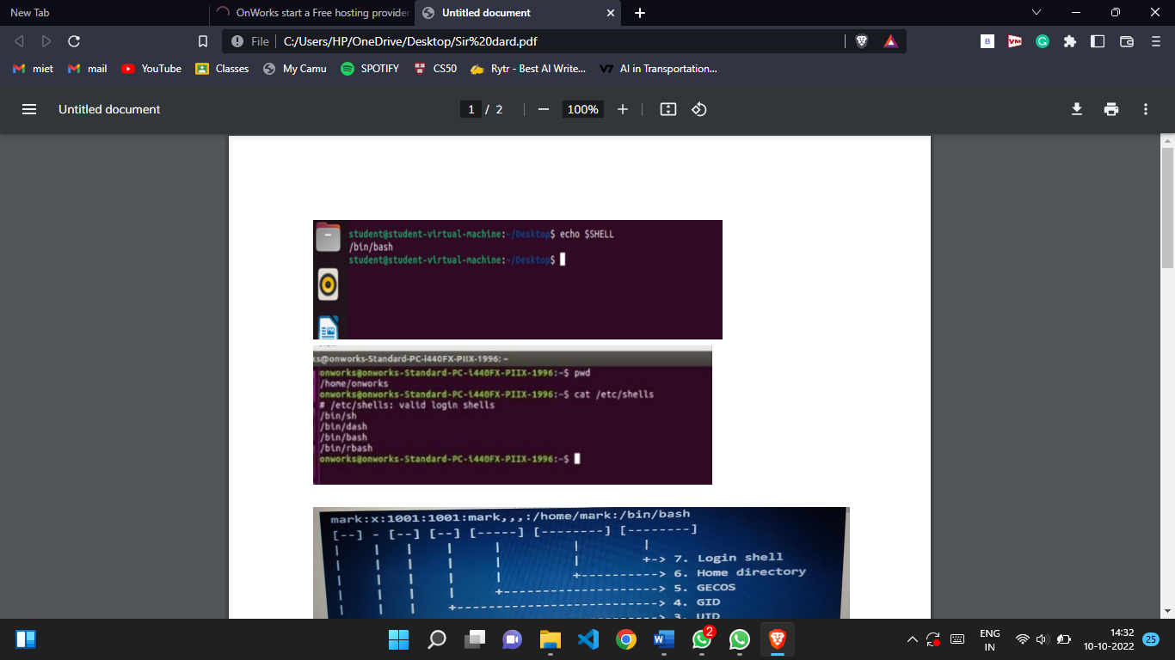

1. To find all available shells

Command :- $cat/etc/shells

Output :- 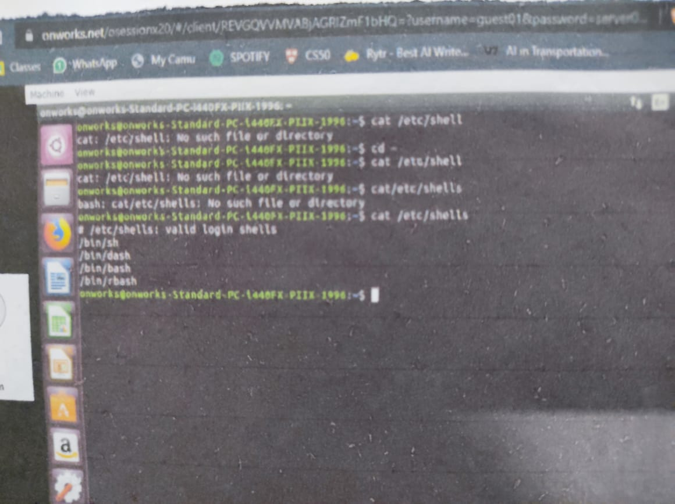

1. Use of

Command :-$cat/etc/passwd

Output :- 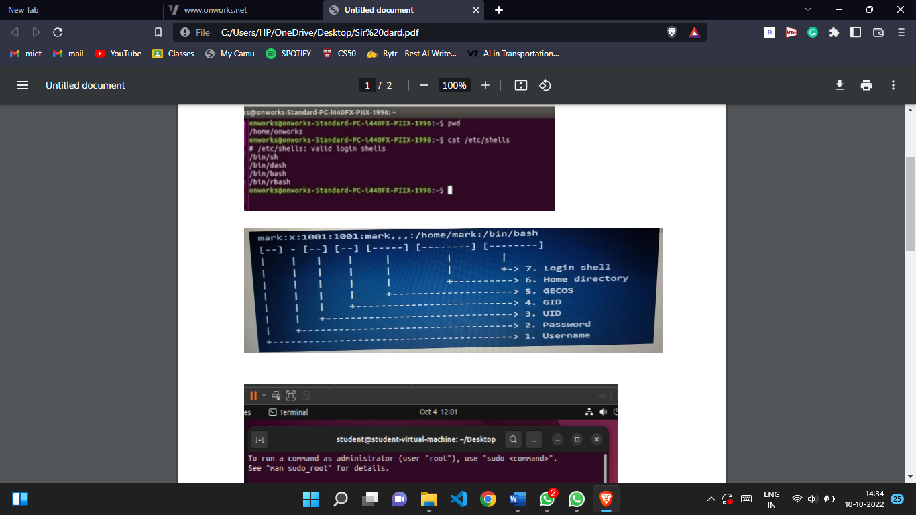

1. Use of ‘who’, ‘more’

Command :- $who-H>myfile1.txt

$more-d myfile1.txt

Output :- 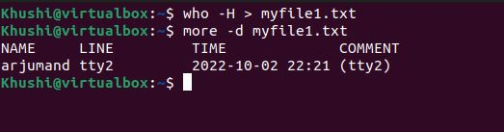

1. Use of

Command :- $date;who-H>myfile2.txt

More-d myfile2.txt

Output :- 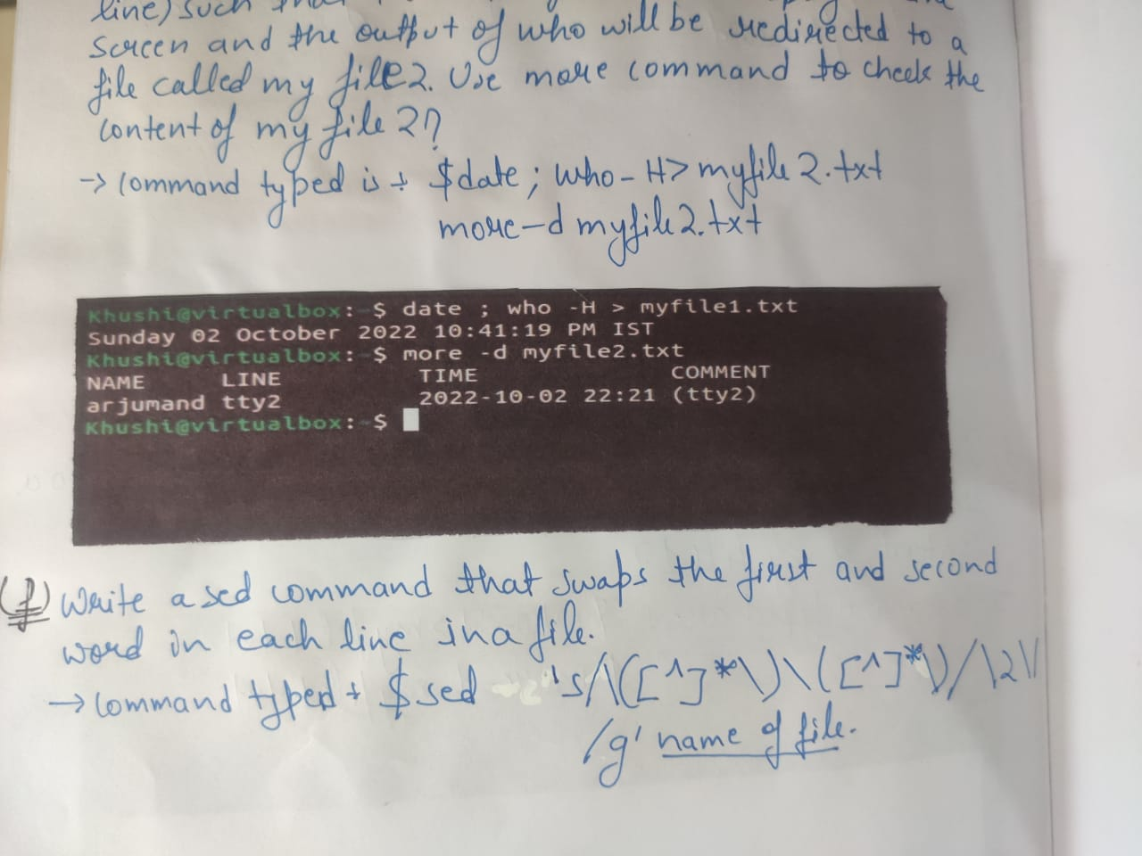

1. To swap the first and second word in each line in a file

Command :- $sed’s/\([^]\*\)\([^]\*\)/\2\//g’ name of file

Output :- 